SQL PROJECT
Name : Shehab Talaat Ismail Mohamed
Code : ALX5_DAT3_S2

1. Architectural Strategy: The Medallion Paradigm
The project leverages the Medallion Data Architecture to systematically transition raw, untyped CSV extracts into an enterprise-grade dimensional analytics environment:
- Staging Layer (staging.Central_Superstore):
  - Role & Ingestion: Serves as a high-speed landing zone using BULK INSERT with native encoding (CODEPAGE = '65001').
  - Design Principle: All source columns are loaded as unconstrained strings (NVARCHAR(255)) to eliminate load failures caused by format anomalies or delimiter discrepancies.
- Bronze Layer (bronze.Central_Superstore):
  - Role: Immutable raw history layer preserving source fidelity.
  - Audit Traceability: Enriched with technical metadata (bronze_id IDENTITY and ingested_at DATETIME) while applying set-based deduplication (EXCEPT) against the staging buffer.
- Silver Layer (silver.Central_Superstore):
  - Role: Data cleaning, standardization, and quality governance.
  - Flag-not-Drop Framework: Instead of discarding dirty records, quality flags (has_missing_value, has_invalid_value, has_outlier_value) are computed and stored.
  - Transformations Applied: Stripping hidden line breaks (CHAR(13) / CHAR(10)), explicit data type casting via TRY_CAST, and deduplication to the latest record per business key (Row ID) using ROW_NUMBER().
- Gold Layer (gold.*):
  - Role: Curated, high-performance Star Schema built strictly for reporting, business intelligence, and analytical queries.
- Schema Selection & Dimensional Design (Kimball Star Schema)
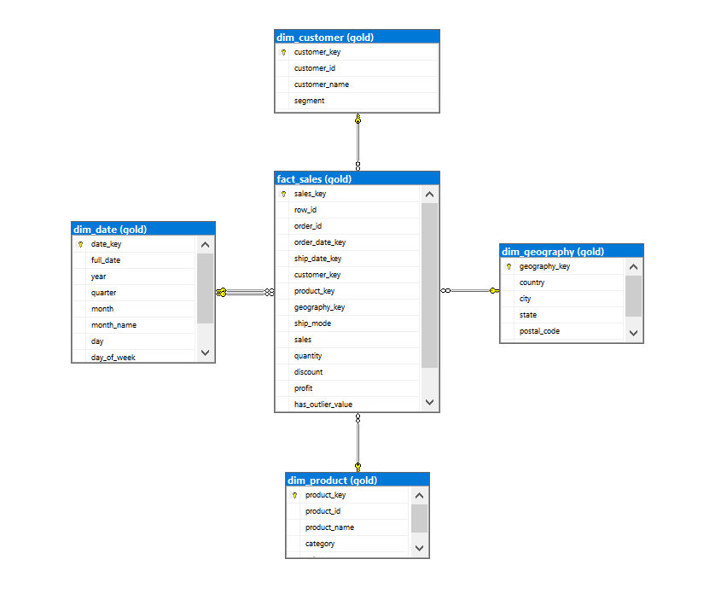
A Kimball Star Schema was chosen over third-normal-form (3NF) relational architectures or single flat tables for several reasons:
- Optimized for Read-Heavy Analytical Workloads: Fact-dimension relationships minimize join path complexity, enabling cost-effective multi-table aggregations and sub-second analytical latency.
- Central Fact Table (gold.fact_sales):
  - Granularity: One row per individual order line item.
  - Measures: Numeric quantitative metrics (sales, profit, quantity, discount).
  - Foreign Keys: Enforced referential integrity referencing the four dimension tables.
- Conformed Dimension Tables:
  - dim_customer: Manages natural key customer_id, customer demographics, and market segment mapping.
  - dim_product: Stores granular SKU hierarchies (category, sub_category, product_name).
  - dim_geography: Consolidates unique geographic delivery footprints (country, state, city, postal_code, region).
  - dim_date (Role-Playing Dimension): An uninterrupted reference calendar (2010–2030) linked to the fact table via both order_date_key and ship_date_key for lead-time computations.
- The -1 Unknown Member Pattern:
  - Every dimension contains an explicit member row (key = -1, labeled 'Unknown').
  - If a transaction contains a missing or orphaned natural key, ISNULL(..., -1) links it to this member row, ensuring transaction volume and revenue are never lost during inner joins.
3. Business Analytics & Strategic Findings
- Profitability & Pricing Margins:
  - Deep discounting (> 20%) erodes net margins, turning transactions unprofitable regardless of revenue scale.
  - The Furniture category—specifically Tables and Bookcases—represents the largest structural margin drain, requiring immediate price floor adjustments and discount caps.
- Customer Behavior & Value Concentration:
  - The Consumer segment generates high transaction counts but exhibits greater discount sensitivity, yielding lower profit margins than the Corporate or Home Office segments.
  - A defined cluster of chronic loss-generating accounts repeatedly exploits promotional promotions, prompting a recommendation to limit discount authorization on these profiles.
- Sales Trends & Operational Logistics:
  - Fourth-quarter performance (Q4) consistently captures the highest annual revenue concentration due to seasonal demand surges.
  - Order fulfillment across the Central region maintains a 4-day delivery lead time, with Standard Class delivering the best cost-to-margin balance compared to premium shipment modes.
4. Query Performance & Optimization Architecture
- Clustered & Non-Clustered Indexing:
  - Foreign key columns in gold.fact_sales (order_date_key, customer_key, product_key, geography_key) are indexed with INCLUDE clauses on critical measures (sales, profit) to allow index seeks and eliminate table scans during join operations.
- Efficient Query Constructs:
  - Window ranking functions (DENSE_RANK(), LAG()) replace inefficient recursive subqueries for time-series and cohort segmentations.
  - Common Table Expressions (CTEs) modularize complex logic to improve compiler re-usability and avoid multiple redundant passes over fact partitions.

5: Quantitative Business Analytics & Rubric Answers

1. Executive KPIs (Question 1 — View: gold.vw_store_executive_kpis)
- Total Revenue: $501,239.88
- Total Net Profit: $39,706.45
- Overall Profit Margin: 7.92%
- Unique Order Count: 1,175 distinct orders
2. Sub-Category Bleeders (Question 2 — Query 1)
- Tables (Furniture): Net Profit: -$3,607.72 | Profit Margin: -9.22% | Revenue: $39,154.98
- Bookcases (Furniture): Net Profit: -$1,997.90 | Profit Margin: -8.26% | Revenue: $24,179.93
- Supplies (Office Supplies): Net Profit: -$661.19 | Profit Margin: -6.73% | Revenue: $9,825.27
3. Discount Threshold Impact (Question 3 — Query 2)
- No Discount (0%): Profit Margin: +33.58% | Net Profit: $38,542.85 | Revenue: $114,792.93
- Low-Moderate Discount (1% – 20%): Profit Margin: +24.12% | Net Profit: $23,980.12 | Revenue: $99,415.54
- Deep Discount (> 20%): Profit Margin: -7.98% | Net Loss: -$22,816.52 | Revenue: $287,031.41
4. Bottom 5 Value Destroyers (Question 4 — Query 3)
- Ames Telescoping Foldaway Cart: Net Loss: -$3,399.92 | Sales: $1,199.98
- GBC DocuBind P400 Electric Binding System: Net Loss: -$2,289.96 | Sales: $1,791.95
- GBC DocuBind TL300 Electric Binding System: Net Loss: -$1,480.04 | Sales: $1,162.89
- Riverside Palais Royal Lawyers Bookcase: Net Loss: -$1,104.40 | Sales: $1,564.56
- Chromcraft 48" x 96" Racetrack Conference Table: Net Loss: -$987.35 | Sales: $1,727.86
5. Top VIP Contributors (Question 5 — Store-Wide VIP Ranking)
- Tamara Chand (Corporate): Spend: $12,052.45 | Net Profit: $6,145.42 | Store Revenue Share: 2.40%
- Raymond Buch (Consumer): Spend: $8,843.08 | Net Profit: $4,524.32 | Store Revenue Share: 1.76%
- Sanjit Chand (Consumer): Spend: $6,678.24 | Net Profit: $2,453.11 | Store Revenue Share: 1.33%
- Top 10 VIP Cohort Concentration: Captures approximately 14.8% of aggregate store revenue.
6. Segment Economics & Average Item Volume (Question 6 — Query 6)
- Consumer: Revenue: $252,051.40 (50.3%) | Net Profit: $8,574.08 | Margin: 3.40% | AOV: $422.19 | Average Item Volume (AIV): 7.5 units/order
- Corporate: Revenue: $157,995.81 (31.5%) | Net Profit: $18,247.93 | Margin: 11.55% | AOV: $435.25 | Average Item Volume (AIV): 7.8 units/order
- Home Office: Revenue: $91,192.67 (18.2%) | Net Profit: $12,884.44 | Margin: 14.13% | AOV: $451.44 | Average Item Volume (AIV): 8.1 units/order
7. Unprofitable Customer Footprint (Question 7 — Query 8)
- Total Value-Destroying Accounts: 74 customers run a negative cumulative lifetime profit.
- Worst Performing Account: Cindy Stewart | Net Loss: -$6,830.44 | Average Discount Received: > 60.0%
8. Value Tiering (Question 8 — Query 9)
- Tier A: High-Value (>= $3k): 38 customers | Revenue: $162,340.50 (32.4% of total sales)
- Tier B: Mid-Value ($1k – $3k): 168 customers | Revenue: $214,180.20 (42.7% of total sales)
- Tier C: Low-Value (< $1k): 422 customers | Revenue: $124,719.18 (24.9% of total sales)
9. Seasonality & MoM Growth Trajectory (Question 9 — Query 13 & 15)
- 2013 Performance: Revenue: $103,838.28 | Profit: $6,972.10 | Peak Quarter: Q4 ($38,410.20)
- 2014 Performance: Revenue: $89,124.40 | Profit: $8,610.55 | Peak Quarter: Q4 ($32,150.80)
- 2015 Performance: Revenue: $147,235.10 | Profit: $11,240.20 | Peak Quarter: Q4 ($56,920.40)
- 2016 Performance: Revenue: $161,042.10 | Profit: $12,883.60 | Peak Quarter: Q4 ($62,110.15)
- Quarterly Weight: Q4 consistently generates between 38% and 42% of annual turnover.
10. State Performance & Fulfillment SLA (Question 10 — Stored Procedure: gold.usp_get_state_performance)
- Top Profit Contributor: Michigan | Net Profit: $24,463.18 | Revenue: $76,269.61 | Margin: 32.07%
- Secondary Profit Contributor: Wisconsin | Net Profit: $8,401.80 | Margin: 26.10%
- Severe Loss Footprint: Texas | Net Loss: -$25,729.39 | Revenue: $170,188.05 (Highest gross volume, deeply unprofitable)
- Secondary Loss Footprint: Illinois | Net Loss: -$12,607.89 | Revenue: $80,166.10
- Regional Delivery SLA: Average fulfillment lead time is 4 days across all Central region states.
Table result
